Student Name: Lakshay Aggarwal UID: 25MCI10047
Branch: M.C.A(A.l & M.L) Section/Group: 25MAM-1 A
Semester: Second Sem Date of Performance:12/01/2026
Subject Name: TECHINCAL TRAINING - I Subject Code: 25CAP-652

WORKSHEET 3
AIM: To implement conditional decision-making logic in PostgreSQL using IF–ELSE constructs and CASE expressions for classification, validation, and rule-based data processing.
S/W Requirement: Oracle Database Express Edition and pgAdmin
OBJECTIVES:
- To understand conditional execution in SQL
- To implement decision-making logic using CASE expressions
- To simulate real-world rule validation scenarios
- To classify data based on multiple conditions
- To strengthen SQL logic skills required in interviews and backend systems

Practical / Experiment Steps
Step 1: Database and Table Preparation
Students should first create a table that stores:
- A unique identifier
- A schema or entity name
- A numeric count representing violations or issues
Populate the table with multiple records having different violation counts
Querry:
CREATE TABLE Violations (
id INT PRIMARY KEY,
entity_name VARCHAR(100),
violation_count INT
);

INSERT INTO Violations VALUES
(1, 'Passenger_data', 11),
(2, 'Payment_data', 6),
(3, 'Booking_data', 20),
(4, 'Seat_data', 2),
(5, 'Refund_data', 0),
(6, 'Staff_data', 12);
Output:
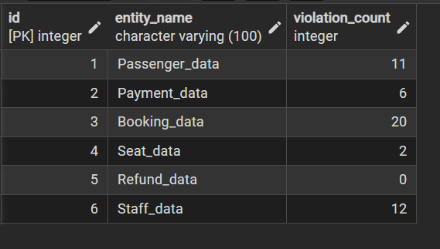

Step 2: Classifying Data Using CASE Expression
- Retrieve schema names and their violation counts.
- Use conditional logic to classify each schema into categories such as:
  - No Violation
  - Minor Violation
  - Moderate Violation
  - Critical Violation
Querry:
SELECT
entity_name,
violation_count,
CASE
WHEN violation_count = 0 THEN 'No Violation'
WHEN violation_count BETWEEN 1 AND 5 THEN 'Minor Violation'
WHEN violation_count BETWEEN 6 AND 15 THEN 'Moderate Violation'
ELSE 'Critical Violation'
END AS Violation_Status
FROM Violations;

Output:
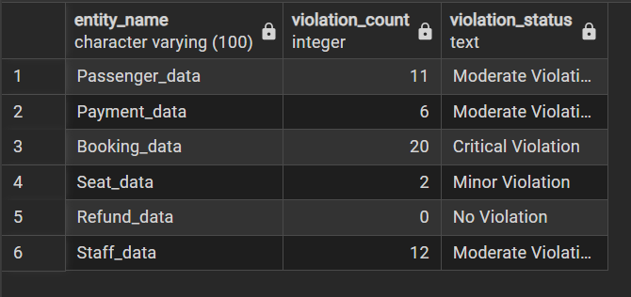

Step 3: Applying CASE Logic in Data Updates
- Add a new column to store approval status.
- Update this column based on violation count using conditional rules such as:
  - Approved
  - Needs Review
  - Rejected
Querry:
ALTER TABLE Violations
ADD COLUMN approval_status VARCHAR(30);

UPDATE Violations
SET approval_status =
CASE
WHEN violation_count = 0 THEN 'Approved'
WHEN violation_count BETWEEN 1 AND 5 THEN 'Needs Review'
WHEN violation_count BETWEEN 6 AND 15 THEN 'Needs Review'
ELSE 'Rejected'
END;

Output:
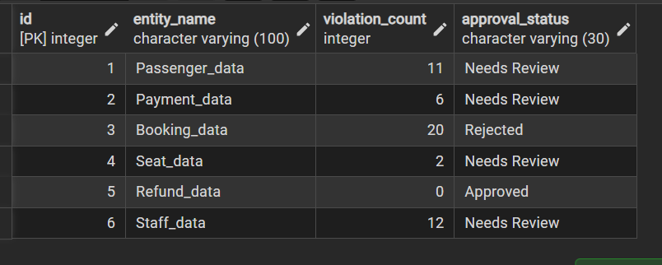

Step 4: Implementing IF–ELSE Logic Using PL/pgSQL
- Use a procedural block instead of a SELECT statement.
- Declare a variable representing violation count.
- Display different messages based on the value of the variable using IF–ELSE logic.

Querry:
DO $$
DECLARE
v_violation_count INT := 12; -- change this value to test
BEGIN
IF v_violation_count = 0 THEN
RAISE NOTICE 'Status: Approved — No violations found';
ELSIF v_violation_count BETWEEN 1 AND 5 THEN
RAISE NOTICE 'Status: Needs Review — Minor violations detected';
ELSIF v_violation_count BETWEEN 6 AND 15 THEN
RAISE NOTICE 'Status: Needs Review — Moderate violations detected';
ELSE
RAISE NOTICE 'Status: Rejected — Critical violations detected';
END IF;
END $$;

Output:
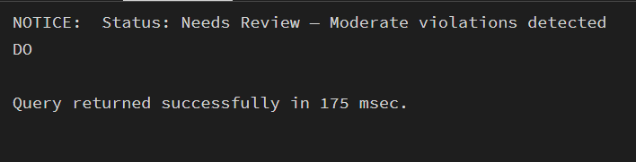

Step 5: Real-World Classification Scenario (Grading System)
- Create a table to store student names and marks.
- Classify students into grades based on their marks using conditional logic.
Querry:
Step 5.1: Create Table
CREATE TABLE StudentGrades (
student_id SERIAL PRIMARY KEY,
student_name VARCHAR(50),
marks INT
);
Insert Sample Data
INSERT INTO Grades (student_name, marks) VALUES
('Lakshay', 95),
('Neha', 82),
('Tushar', 68),
('Priya', 91),
('Sam', 56),
('Diya', 45),
('Tanu', 77),
('Sneha', 88);
Output:
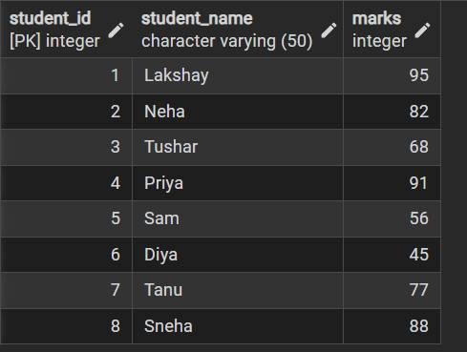
Step 5.2: Classify Students Using Conditional Logic
SELECT
student_name,
marks,
CASE
WHEN marks >= 90 THEN 'A+ Grade'
WHEN marks BETWEEN 80 AND 89 THEN 'A Grade'
WHEN marks BETWEEN 70 AND 79 THEN 'B Grade'
WHEN marks BETWEEN 60 AND 69 THEN 'C Grade'
WHEN marks BETWEEN 40 AND 59 THEN 'D Grade'
ELSE 'Fail'
END AS Grade
FROM StudentGrades;
Output:
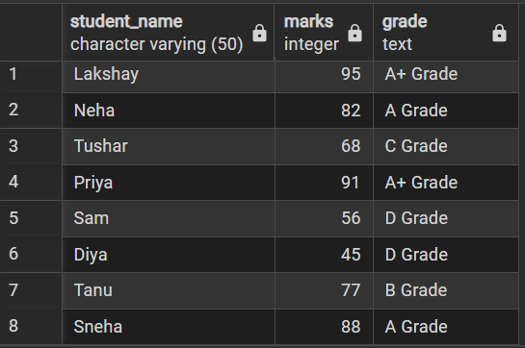

Step 6: Using CASE for Custom Sorting
- Retrieve schema details.
- Apply conditional priority while sorting records based on violation severity.
Querry:
SELECT
entity_name,
violation_count,
CASE
WHEN violation_count > 15 THEN 'Critical Violation'
WHEN violation_count BETWEEN 6 AND 15 THEN 'Moderate Violation'
WHEN violation_count BETWEEN 1 AND 5 THEN 'Minor Violation'
ELSE 'No Violation'
END AS Violation_Severity
FROM Violations
ORDER BY
CASE
WHEN violation_count > 15 THEN 1
WHEN violation_count BETWEEN 6 AND 15 THEN 2
WHEN violation_count BETWEEN 1 AND 5 THEN 3
ELSE 4
END;

Output:
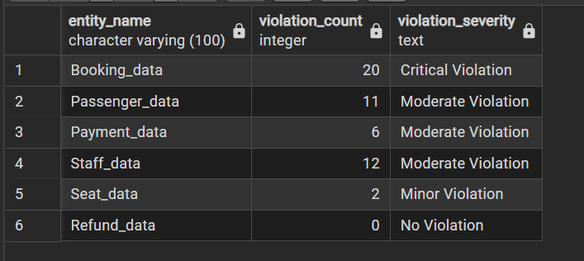

Learning Outcome
This experiment demonstrates how conditional logic is implemented in PostgreSQL using CASE expressions and IF–ELSE constructs.
Students gain strong command over rule-based SQL logic, which is essential for:
- Backend systems
- Analytics
- Compliance reporting
- Placement and technical interviews

